Physics 11

Waves Test

|  |  |
| --- | --- |
| Student Name |  |

**Time allowed for this paper**

Reading time before commencing work: 5 minutes (at option of teacher)

Working time for paper: 60 minutes

**To be provided by the supervisor:**

This Question/answer booklet;

Formulae and constants sheet

**To be provided by the candidate**

Standard items: Pens, pencils, eraser or correction fluid, ruler, highlighter

Special items: Drawing instruments or templates.

A **scientific** (i.e. non graphics) calculator satisfying curriculum council requirements.

**Structure of this paper**

|  |  |  |  |  |  |
| --- | --- | --- | --- | --- | --- |
| Section | Number of questions available | Suggested working time  (minutes) | Your Mark | Marks available | Percentage of test |
| Section One:  Short answer | 7 | 25 |  | 19 | 35 |
| Section Two:  Extended answer | 4 | 35 |  | 33 | 65 |
|  |  | **Total** |  | 52 |  |

**Instructions to candidates**

1. To achieve full marks, clear, logical working and diagrams MUST be shown.
2. When calculating numerical answers, show your working or reasoning clearly. Give final answers to **three** significant figures and include appropriate units where applicable. Estimates should be to two significant figures.

**Section One: 8 Short answers ( 22 marks)**

**Question 1**

Three students are using a piece of string to make a standing wave. The following graph shows the wavelength of part of the string at one particular instance.

Examine the graph and determine the waves:

Amplitude ______________________________

Wavelength ____________________________ **(2 marks)**

**Question 2**

If the wave in the graph for question (1) is travelling at 21.00 ms-1, what is the period of the wave?

**(3 marks)**

**Question 3**

Using the space below, complete the following diagrams for **reflection** of waves at a harbour wall and the **refraction** of the sound of a bell as it enters the air from the water.

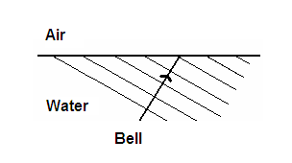

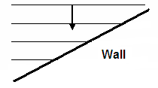

**(3 marks)**

**Question 4**

Complete the diagrams below which show water waves encountering an opening in a barrier.

Barrier

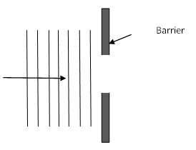

**(2 marks)**

**Question 5**

A long tube is held over some water so that one end was effectively closed and the other open. A tuning fork is struck and held above the open end. It seems that the tuning fork has inexplicably become louder. Explain in detail what the phenomenon is that causes this increase in loudness and how it happens.

**(3 marks)**

**Question 6**

Draw a diagram of pressure variation for the fundamental harmonic in a closed tube (show the position of all nodes and antinodes). Use this to determine the length of a tube required to produce a fundamental frequency of 256 Hz?

**(3 marks)**

**Question 7**

Outline the conditions that must be met for a standing wave to be produced. Be specific with your terminology.

**(3 marks)**

**End Section A**

**Section Two: Extended answers (33 marks)**

**Question 8 (3 marks)**

Two pulses on a string approach each other as shown below.



1. On the grid below, draw in one colour the positions of the two individual pulses

2 seconds after their positions shown in the diagram above. (2 marks)

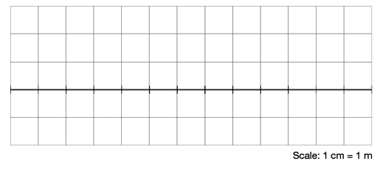

1. Then draw in another colour the **superposition** of the two pulses at this time.

(1 mark)

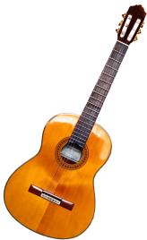**Question 9 (9 marks)**

A 45 cm guitar string with a fundamental frequency of 216 Hz is vibrating at the third harmonic. The speed of sound in the room is 330 m s–1.

a) Draw the vibrating string, showing the nodes and antinodes.

(1 mark)

b) What is the wavelength of the third harmonic?

(2 marks)

c) What is the frequency of the third harmonic? Show all working or reasoning.

(2 marks)

d) What is the speed of the waves in the string?

(2 marks)

e) If the upper limit of human hearing is 20 kHz, which is the lowest harmonic that can be heard?

(2 marks)

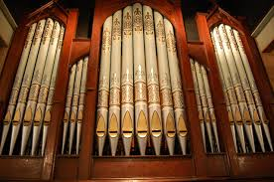**Question 10 (8 marks)**

In the concert hall, the speed of sound was measured at

332 ms–1. One of the pipes attached to the organ is 50 cm long and open at both ends.

a) Draw a diagram of the tube showing the particle displacement of the fundamental harmonic.

(1 mark)

b) What is the fundamental wavelength?

(2 mark)

c) What is the fundamental frequency?

(2 mark)

d) Draw the particle displacement diagram and then determine the frequency of the fifth harmonic?

(3 marks)

**Question 11 (13 marks)**

The driver of an SES vehicle turns on **two loud speakers** which are mounted 2.00 m apart on the roof of the vehicle. The speakers emit a single tone warning sound which leaves each speaker in phase.

### 

Loudspeakers

a) If a bystander walks in front of the car, from points T to P, what will he observe?

(2 marks)

b) An observer stands at point S.

i. What is the path difference (in metres) between the speakers and the observer?

(3 marks)

ii. If the frequency of the warning sound is 1500Hz, what is the path difference in terms of wavelength (assume velocity of sound in air is 346 ms-1)?

(2 marks)

iii. At this point do the waves from both speakers constructively interfere? Explain your answer.

(2 marks)

c) The observer at point S begins to walk towards point T. How many antinodes will he pass through on the way from S to T? Show all working and any diagrams necessary.

(4 marks)

**End of Test**